# **Operational Concept Description (OCD)**

**Newlette Coins**

**Team Number - 06**

|  |  |  |  |  |
| --- | --- | --- | --- | --- |
| **Members** | **Name** | **Email** | **Primary Role** | **Secondary Role** |
|  | Akshaya Ravichandran | ravichaa@usc.edu | Requirements Engineer | UML Modeler |
|  | John Leibowitz | jleibowi@usc.edu | IIV&V | Quality Focal Point |
|  | Nitin Surana | [nsurana@usc.edu](mailto:nsurana@usc.edu) | Life Cycle Planner | Software Architect |
|  | Remya Ramachandran | remyaram@usc.edu | Feasibility Analyst | Implementer |
|  | Santhoshi Priyanka Gooty Agraharam | gootyagr@usc.edu | Project Manager | Tester |
|  | Theerapat Chawannakul | tchawann@usc.edu | Builder | Implementer |
|  | Vujjini Anuraag | vujjini@usc.edu | Implementer | Prototyper |

# 

# 

# 

# 

# 

# 

# Version History

|  |  |  |  |  |
| --- | --- | --- | --- | --- |
| **Date** | **Author** | **Version** | **Changes made** | **Rationale** |
| 10/09/16 | PG | 1.0 | * Initial draft | * Initial draft |
| 10/13/16 | AR | 1.1 | * System Boundary and Environment Diagram update | * Update according to ARB feedback |

# 

# 

# **Table of Contents**

*Operational Concept Description (OCD)*

*Version History* *3*

*Table of Contents* *4*

*Table of Tables* *5*

*Table of Figures* *6*

*1. Introduction*

*1.1. Purpose of the OCD* *7*

*1.2. Status of the OCD* *7*

*2. Shared Vision*

*2.1. Overview of the system* *7*

*Table 1: The Newlette Coins Program Model* *7*

*2.2. Benefit Chain* *8*

*Figure 1: Benefits Chain Diagram of Newlette Coins* *_ 8*

*2.3. System Capability Description* *9*

*2.4. System Boundary and Environment* *9*

*Figure 2: System Boundary and Environment Diagram* *9*

*3. System Transformation*

*3.1. Information on Current System* *10*

*3.1.1. Infrastructure* *10*

*3.2. System Objectives, Constraints and Priorities* *10*

*3.2.1. Capability Goals* *10*

*Table 2: Operational Capability Goals of Newlette Coins* *10*

*3.2.2. Level of Service Goals* *11*

*Table 3: Level of Service Goals* *11*

*3.2.3 Organizational Goals* *11*

*3.2.4 Constraints* *11*

*3.3. Proposed New Operational Concept* *12*

*3.3.1. Element Relationship Diagram* *12*

*Figure 3: Element Relationship Diagram* *12*

*3.3.2. Business Workflows* *13*

*Figure 4: Business Workflow Diagram* *13*

*3.4. Organizational and Operational Implications*

*3.4.1. Organizational Transformations* *14*

*3.4.2. Operational Transformations* *14*

# **Table of Tables**

*Table 1: The Program Model* 7

*Table 2: Operational Capability Goals* *8*

*Table 3: Level of Service Goals* *11*

# **Table of Figures**

*Figure 1: Benefits Chain Diagram* *8*

*Figure 2: System Boundary and Environment Diagram* *9*

*Figure 3: Element Relationship Diagram* *12*

*Figure 4: Business Workflow Diagram* *13*

### 1. Introduction

#### 1.1. Purpose of the OCD

This document explores the shared visions and the value propositions of the stakeholders of the Newlette Coins project. The success-critical stakeholders of the project are Ankush H Prasad, as the project owner and maintainer; the game players as users.

#### 1.2. Status of the OCD

The status of the OCD is currently at version number 1.1

### 2. Shared Vision

#### 2.1. Overview of the system

|  |  |  |  |
| --- | --- | --- | --- |
| **Assumptions:** There are many users who like to spend their time playing online board games. Ours is the only board game with such a concept in the market by the time of release. | | | |
| **Stakeholders** | **Initiatives** | **Value Propositions** | **Beneficiaries** |
| * Gamers / Users * Developer * Maintainers * Client * Marketers | * Play the game. * Design and develop the new game as per requirements. * Provide requirements, oversee progress. * Extend support to maintain the system. * Design brochures, campaigns and devise strategies to publicize the game. | * Break from routine life by providing innovative gaming experience. * Increase client’s current user-base. * Increase company’s brand and market value. | * Game lovers of any age group. * Client -Crazy Cool Apps LLC |
| **Cost**   * Maintenance cost (1 half/full time person) * Web Server (Amazon Servers) * No licensing fees because open source technologies & frameworks are used. * No development costs. | | **Benefit (Metrics):**   * Increased percentage growth in the current user-base of the company. * Increased market value of the company which can help in attracting potential investors. * Increased revenue. | |

###### Table 1: The Newlette Coins Program Model

#### 2.2. Benefit Chain

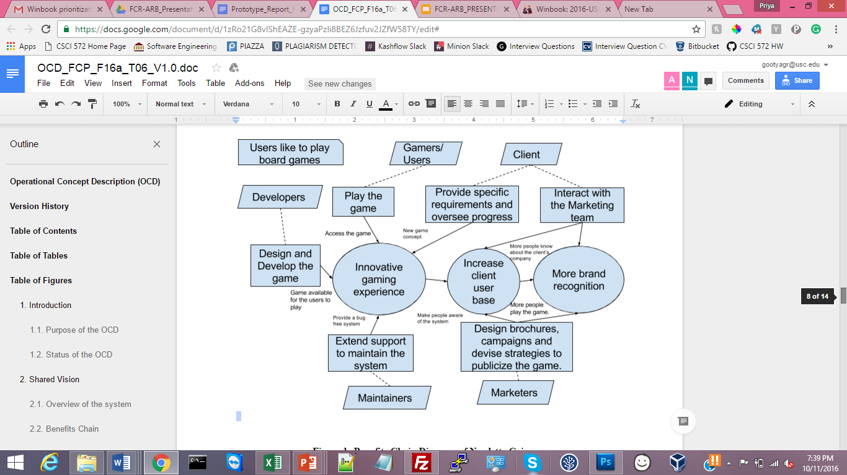

###### Figure 1: Benefits Chain Diagram of Newlette Coins

#### 2.3. System Capability Description

Newlette Coins is a web-based board game built using the HTML5 technology framework. The game works on just any device. The game is super intuitive for users of all ages. The feel of winning points just by placing bombs and moving up in the leaderboard makes it addictive. There is no similar board game in the market.

#### 2.4. System Boundary and Environment

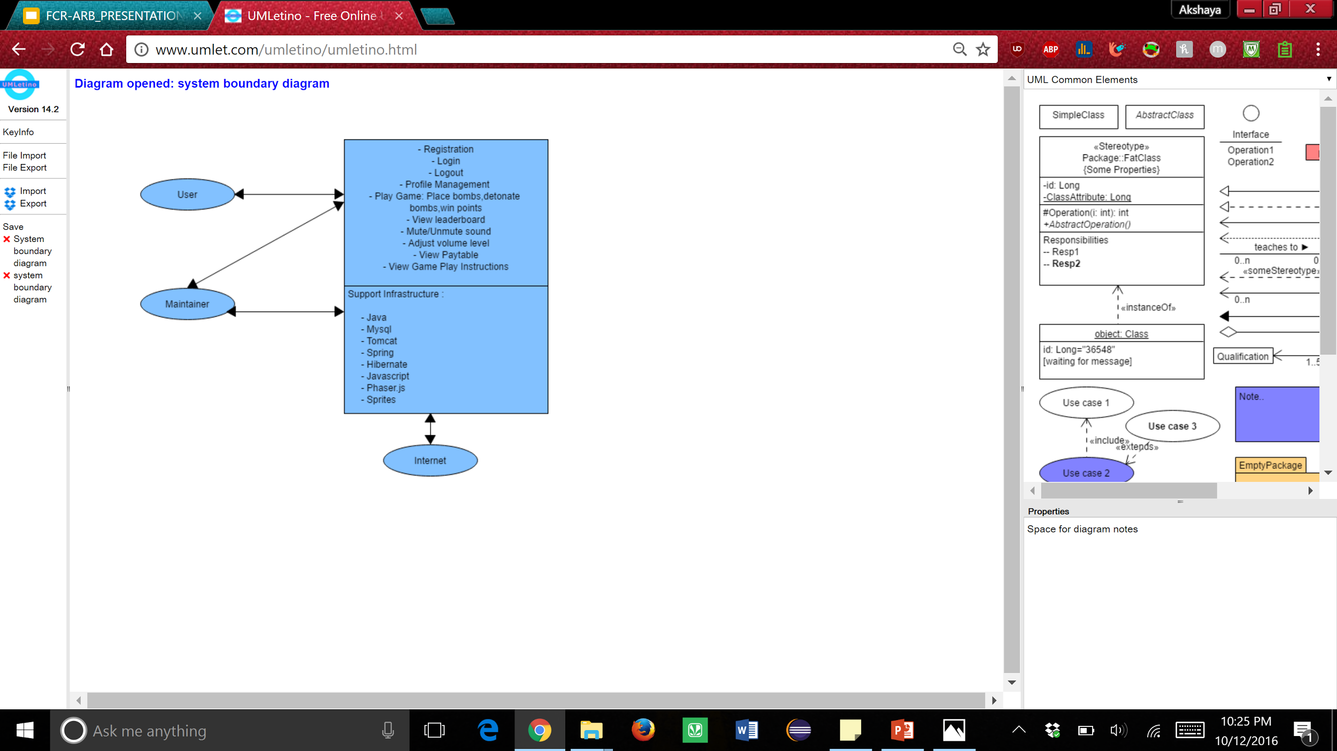

Legend: List of Services:  Stakeholders and systems : 

Figure 2: System Boundary and Environment Diagram

### 3. System Transformation

#### 3.1. Information on Current System

##### 3.1.1. Infrastructure

There is no similar product in the market. We are developing this system from scratch.

#### 3.2. System Objectives, Constraints and Priorities

##### 3.2.1. Capability Goals

Newlette Coins is a system that will allow users to sign up for an account and play the game. The user has an option to choose the multiplier with which he can play the game. He can place bombs on the board and click detonate. Once the bombs detonate, he will gain points depending on what multiplier he chose and what prize he gets after the bomb detonates.

LEGEND: 5=Must have……..1=Optional

|  |  |
| --- | --- |
| **Capability Goals** | **Priority Level** |
| OC-1:User SignUp/Login: Users can sign up by creating account and then can log into the Newlette Coins System. | **5** |
| OC-2:Paytable Calculation: Calculates and displays the number of points won after detonating bombs according to paytable scenarios. | **5** |
| OC-3:Edit Profile: Users can edit their general profile information-first name,last name password and email. | **4** |
| OC-4: Leaderboard: Top 5 scores are calculated and displayed. | **2** |

###### Table 2: Operational Capability Goals of Newlette Coins

##### 3.2.2. Level of Service Goals

|  |  |  |
| --- | --- | --- |
| **Level of Service Goals** | **Priority Level** | **Referred Win-Win Agreements** |
| **LOS-1:** The system shall be scalable for the growing amount of users in the future. (20 simultaneous users) | 4 | WC_4028 |
| **LOS-2:** The system shall be compatible with all browsers (chrome, firefox, safari) and there shall not be any responsive issues with the game for different versions of the browser (last 3 releases) on different platforms including windows 8/10, MacOs 10+, android 4+, ios 9+. | 5 | WC_3939 |

###### Table 3: Level of Service Goals

##### 3.2.3 Organizational Goals

* OG-1: Provide innovative gaming experience to the users.
* OG-2: Increase brand recognition and market value of the company.
* OG-3: Increase current client user base and expand client’s business.

##### 3.2.4 Constraints

**CO-1:** **Phaser.js as a framework:** The client indicates that we must use Phaser.js Framework to create this product

**CO-2:** **Java as a programming language for backend server**

**CO-3: Total game size (including assets) should not exceed more than 15MB**

#### 3.3. Proposed New Operational Concept

##### 3.3.1. Element Relationship Diagram

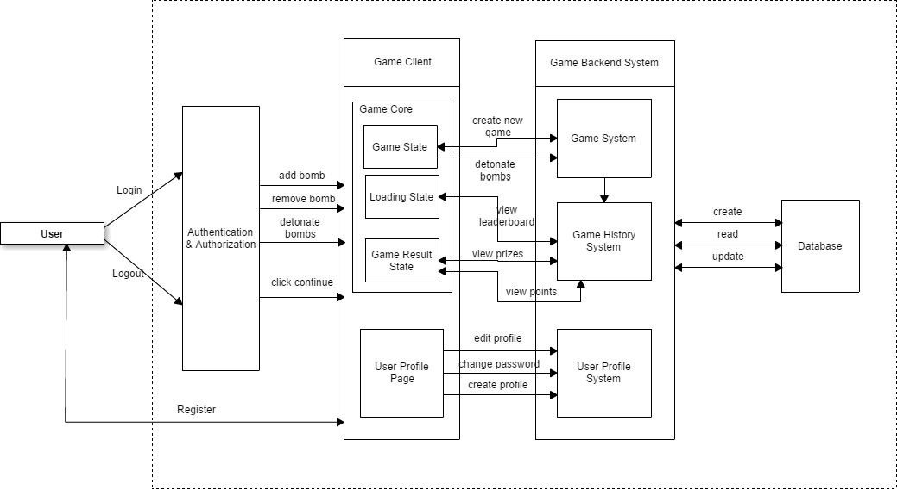

###### Figure 3: Element Relationship Diagram

##### 3.3.2. Business Workflows

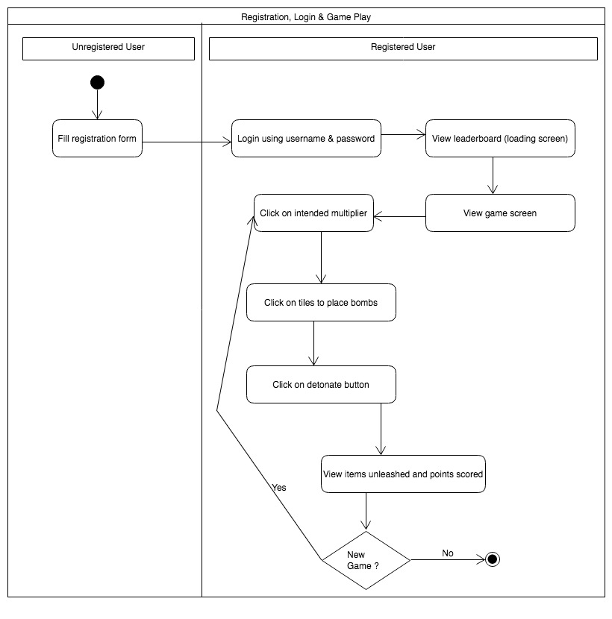

###### Figure 4: Business Workflow Diagram

#### 3.4. Organizational and Operational Implications

##### 3.4.1. Organizational Transformations

There is no current or similar system like the one we are developing in the market. We are building this system from scratch. The owner of this system will be our client Ankush H Prasad. He will also be the maintainer of the project. This system is designed and developed by our team whose roles and responsibilities are as mentioned at the start of this document.

##### 3.4.2. Operational Transformations

Since we build our system from scratch, we do not have any Operational Transformations.